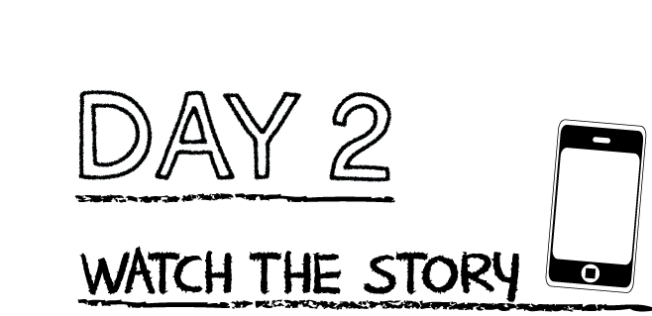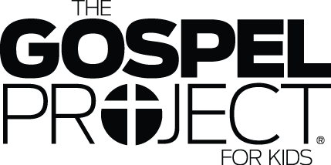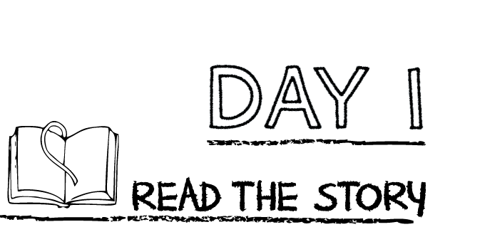

**Answer the following questions.**

What was the first commandment? ____________________________________________________

What were the commandments written on? ___________________________________________

______________________________________________________________________________________

Why do you think God gave the Israelites The Ten Commandments? ____________________

______________________________________________________________________________________

**Prayer:** Lord help me to obey you. I know I don’t always obey you, and I am so thankful that you forgive me when I do not obey you. Help me to follow you. Amen.

**Read the story “The Ten Commandments”**

K-1st grade: Read page 36 of the Big Picture Interactive Storybook Bible

2nd-3rd grade: Read Exodus 20:1-17 and 31:18

Watch the story, “The Ten Commandments” on the RidgeKids Teays Valley Facebook group.

Videos are posted on Facebook every Sunday through RidgeKids Online.

**Prayer:** Dear God, thank you for your commandments that teach me how to live to honor you. Help me to love you and love others. Amen.

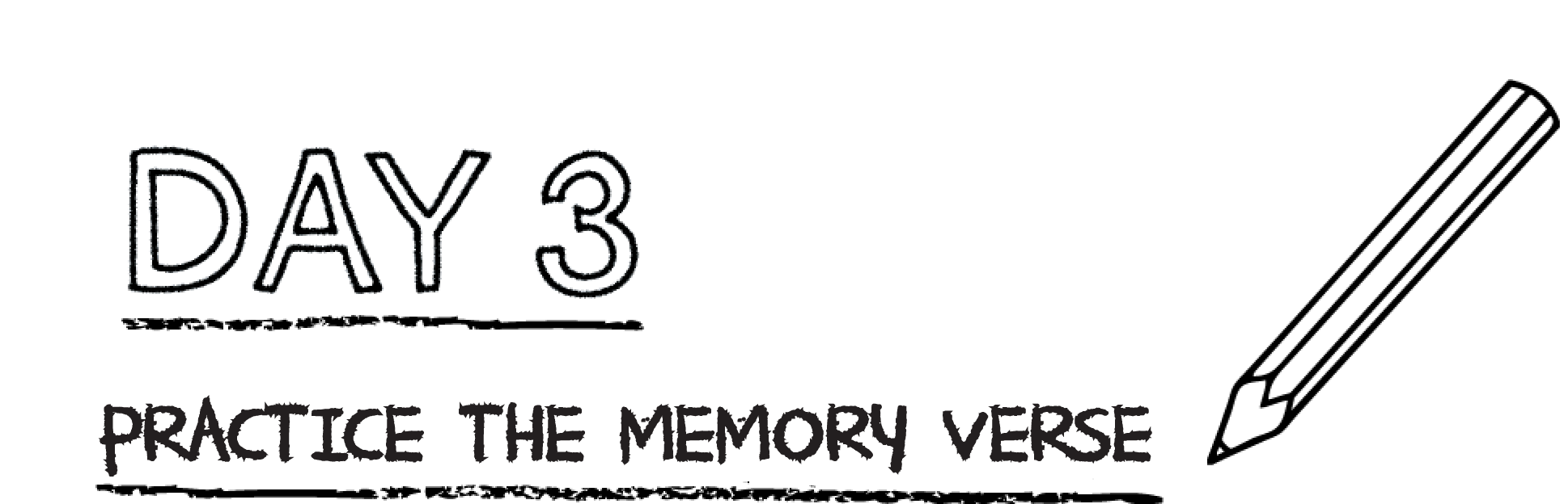

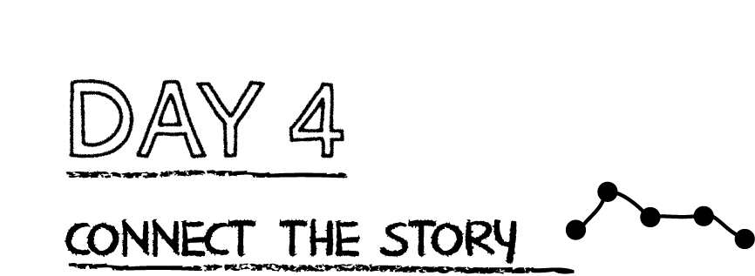

**God is holy and separate from sin. His law shows us what He requires—perfect**

**righteousness. Our sin separates us from God, but Jesus came to bring us back**

**to God. Jesus is perfectly righteous. When we trust in Jesus, He takes away our sin**

**and welcomes us into God’s family.**

Draw a mountain on the left and a mountain on the right. Draw or write “God” on the left and yourself on the right. Notice the space that separates the two mountains. Write sin in this space. Draw a cross to connect the two mountains and write “Jesus” on that cross.

**Pray:** Lord, thank you for sending Jesus to bridge the gap between us. You knew I could never fix my own sin problem or obey all of your commands. I am so thankful for Jesus and his death that pays for my sins. Amen.

**Grab a sheet of paper and trace both of your hands. Write the first sentence from the memory verse on your left hand. Now, write the second sentence from the memory verse on top of your paper like a banner. Write the last sentence on your right hand. Hang up your work somewhere you will see it this week.**

“He said to him, ‘Love the Lord your God with all your heart,

with all your soul, and with all your mind. This is the greatest and most important command. The second is like it: Love your neighbor as yourself.’”

Matthew 22:37-39 CSB

**Pray:** Lord, help to love you with my whole heart and love others as myself. These are your greatest commandments and I want to follow you. Amen.

*.*