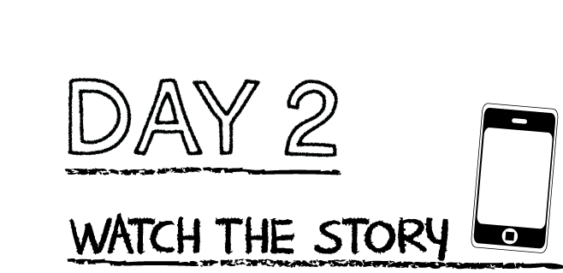

**Answer the following questions:**

Describe 2 things from Revelation 21:1-4 that Joh saw in his vision about the new heaven and new earth.

1.________________________________________________________________________________

2._________________________________________________________________________________

**Fill in the blank from Revelation 22:7 CSB**

“Look, I am coming ________________!”

**Read the story “Jesus Will Return”**

K-1st grade: Read page 294 of the Big Picture Interactive Storybook Bible

2nd-3rd grade: Revelation 21:1-4 and 22:7 of the Big Picture Interactive Bible

Watch the story, “Jesus Will Return” on the RidgeKids Teays Valley Facebook group.

Videos are posted on Facebook every Monday.

**Prayer:** Dear Jesus, help me to believe that you will come back soon. Help me to look forward to the amazing new heaven and new earth that you will create. Amen.

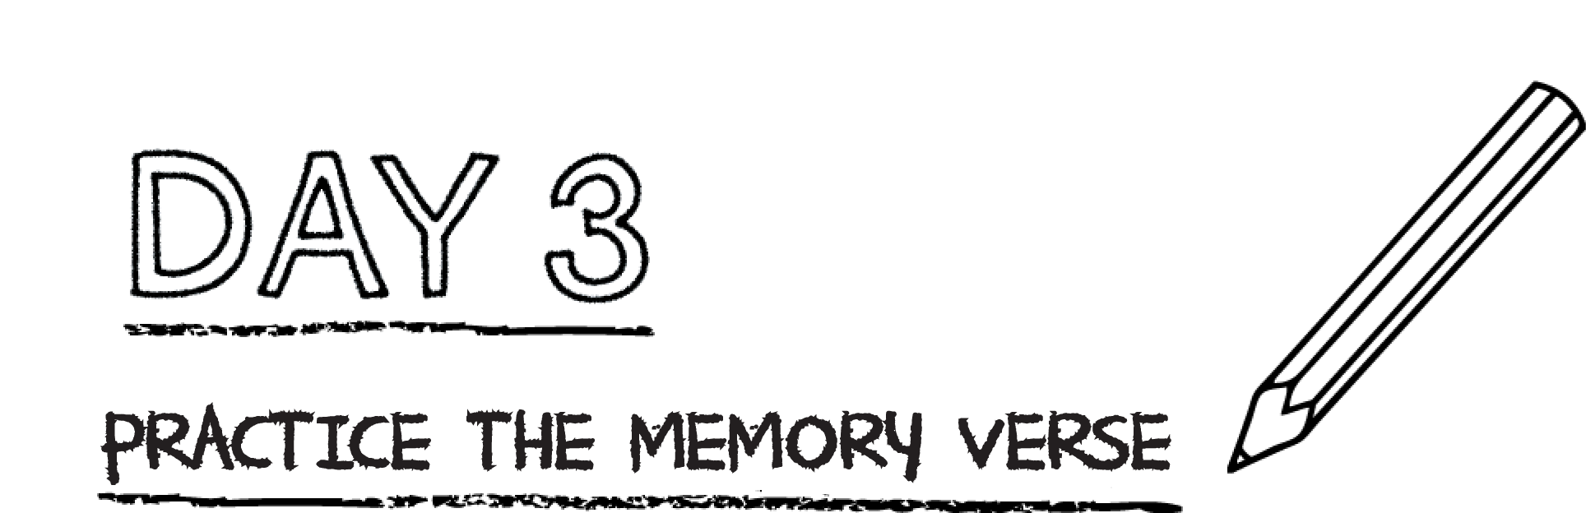



**Find the five incorrect words in the passage below. Mark them with an “X” and write the correct word above it.**

“Then the guy seated on the couch said, ‘Look, I am making some things new.’ He also said, “Write, because these words are good and clean.’”

**Prayer:** Dear God, thank you for your word. Help me to remember this promise, that you Jesus, are seated on the throne and that one day you will come and make all things new. Amen.

*.*

Jesus promised to come back to earth soon. When Jesus returns, those who trust in Jesus will be with Him and enjoy Him forever. God will undo every bad thing caused by sin—no more death, no more pain, no more tears. Jesus is making all things new.

**Read Revelation 21:4. Which part of this verse sounds the best to you?**

**_____________________________________________________________________________**

**_____________________________________________________________________________**

**Read Revelation 22:4-5.** **What will be different about light?** _____________________________________________________________________________

**Prayer:** Dear God, I can’t imagine what the new heaven and new earth will be like. Thank you so much that you came to die for my sin so that I can have eternal life with you. Amen.