

**Answer the following questions true or false.**

________ In the garden of Eden, God gave Adam and Eve lots and lots of rules.

________ Eve said that if they eat from the tree in the middle of the garden or even touch it, they would die.

_______ The serpent tempted Eve to eat the fruit.

_______ Adam ate the fruit first and then gave some to Eve.

_______ Adam and Eve disobeyed God and were punished for their sin.

Watch the story, “Sin Entered the World” on the RidgeKids Teays Valley Facebook group.

Videos are posted on Facebook every Monday.

**Prayer:** God, we know that we are all sinners. No one could ever live a life without sin. Thank you that even from the time when Adam and Eve lived, you have always known we would need a Savior. Amen.

**Read the story “Sin Entered the World”**

K-1st: Read page 4 of the Big Picture Interactive Storybook Bible

2nd -3rd grade: Read Genesis 3:1-13, 23 in the Big Picture Interactive Bible

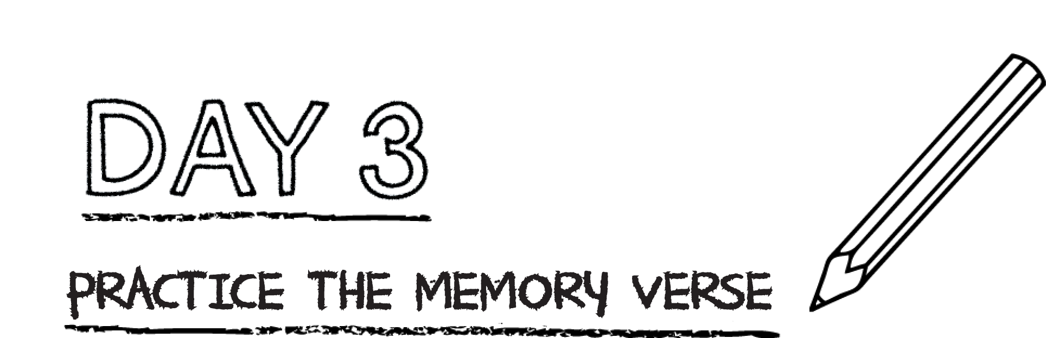

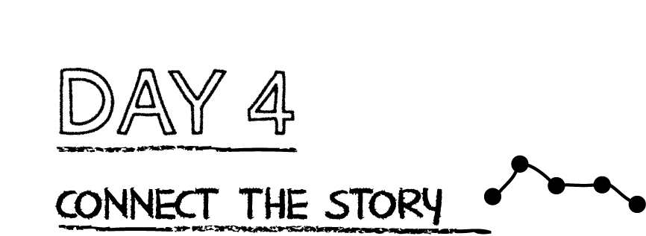

**Fill in the missing words from Colossians 1:16b-17 using the Christian Standard Bible.**

All things have been ________________ through ___________ and for

_______________. He is before all things and by _________________all things

__________________ together.

**Prayer:** It is so amazing Jesus that all things were created by you and through you! You have always been apart of God’s plan, even from the creation of the world. Amen.

*.*

Ever since Adam and Eve sinned, all people have been sinners. Our sin

separates us from God, but God still loves us. God promised a Rescuer would

come from Eve’s family. God sent His Son, Jesus, to rescue people from sin

and bring them back to God.

**Read Psalm Romans 3:23**

Who has sinned? _____________________________________________________________

**Read Romans 5:8** According to this verse, when did Jesus die for you?

___________________________________________________________________________________________________

**Pray and thank God for sending Jesus to die and pay for your sin even when you were still a sinner.**