

**Matthew 1:18-23**

**What is your favorite part of the verse?________________________________________**

**_____________________________________________________________________________**

**How can you apply this verse to your life?_____________________________________**

**_____________________________________________________________________________**

**Write a prayer about this verse to God:** _______________________________________

_____________________________________________________________________________

_____________________________________________________________________________

**Place the numbers 1-5**

________ Mary and Joseph looked for a place to have the baby but every inn was full.

________ An angel appeared to shepherds to announce the birth of Jesus.

________ The Shepherds praised God for all they had seen and heard.

_______ Caesar ordered everyone to be registered for a census.

________ Jesus was born where the animals were kept.

**Read the story “Jesus was Born”**

Read Luke 2:1-20 of the Big Picture Interactive Bible

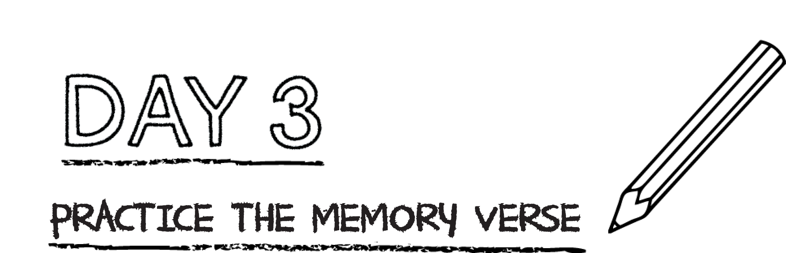



**Using the numbers 1-12, place the verse in the correct order.**

_____so that we might

_____receive adoption

_____under the law,

_____God sent his Son,

_____born of a woman,

_____When the

_____to completion,

_____born under the law,

_____as sons.”

_____Galatians 4:4-5 CSB

_____to redeem those

_____time came



**The birth of Jesus was good news! Jesus was not an ordinary baby. He was God’s Son sent to earth from heaven. Jesus came into the world to save people from their sins and to be their King.**

What is the most important thing to remember about Christmas? _________________

_______________________________________________________________________________

What kinds of things are fun to do at Christmas but not really about Jesus?

_______________________________________________________________________________

_______________________________________________________________________________

How can you help your family and friends remember the most important thing about Christmas this week? ___________________________________________________

______________________________________________________________________________

**Pray and ask God to help you remember the good news of Jesus during Christmas this year.**