

**True or False?**

________ God told Abraham to offer his son Isaac as a sacrifice

________ Abraham ran away and hid from God.

________ Isaac saw that something was missing for the sacrifice.

________ Abraham trusted that God would provide a lamb for the sacrifice.

________ An angel of the Lord appeared and told Abraham to stop.

________ Abraham sacrificed a lamb that he had packed in his supplies.

________The Angel of the Lord told Abraham that God would bless him.

**Prayer:** Dear God, this is a very hard story to understand, but I do know that you provided Jesus as a sacrifice for my sin and I am so thankful that I do not have to pay for my sin because you paid the price for me. Amen.

**Read the story “God Tested Abraham”**

K-1st: Read page 16 of the Big Picture Interactive Storybook Bible

2nd -3rd grade: Read Genesis 22:1-19 in the Big Picture Interactive Bible

Watch the story, “Abraham and Isaac” on the RidgeKids Teays Valley Facebook group.

Videos are posted on Facebook every Monday.

**Prayer:** God, you are an amazing provider. You knew that we would not be able to pay for our sin on our own. You always provide a sacrifice for sin. Amen.

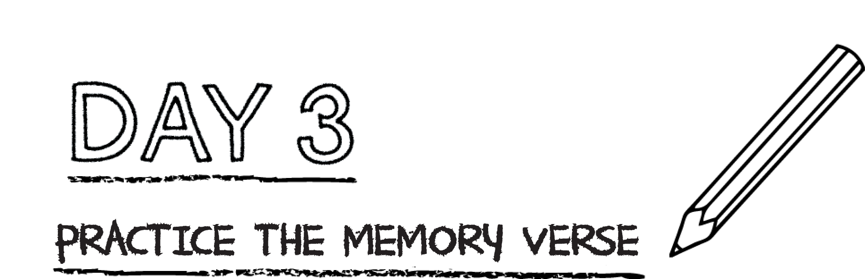



**Practice the memory verse by reciting it three times. Then fill in the blanks below.**

“And if you _________________________ to __________________, then you are

________________________ seed, heirs according to the _________________.”

Galatians 3:29 CSB

**Prayer:** Dear God, I am so thankful that I belong to Christ. I believe in Jesus and his death on the cross for my sin. Amen.

*.*

Abraham showed his love for God by being willing to sacrifice his son Isaac. God provided a ram instead. This is how God showed his love for us: He sent His Son, Jesus, to die on the cross so that we could have eternal life through Him.

**Draw a picture of Abraham and Isaac sacrificing the ram on the left for their sin. Then, draw a picture of Jesus on the cross sacrificed for your sin.**

|  |  |
| --- | --- |
|  |  |

**Prayer:** Dear God, I understand that sin requires a sacrifice. It always has. Help me to understand that you gave your son to pay for my sin. Thank you God for saving me from sin. Amen.