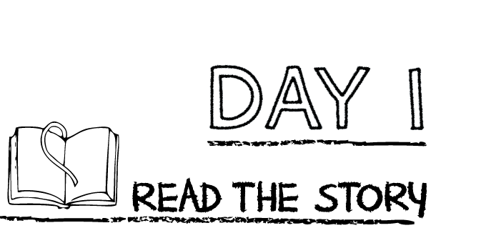

**Place the following statement from the story in order using the number 1-4.**

_______Pharaoh ordered for all the Israelite baby boys to be killed.

_______God told Moses to lead his people out of Egypt to a good land that he had for them.

_______ One day, when Moses was grownup, he saw a burning bush and hear God call.

_______ A woman gave birth to a son and place him in a basket in the Nile River.

**Prayer:** Dear God, thank you for rescuing Moses’ life and using him to rescue the Israelite people.

**Read the story “Moses Was Born and Called”**

K-1st: Read page 28 in the Big Picture Storybook Bible

2nd-3rd grade: Read Genesis 42:1-3, 7-8, 43:29-31, 45:1-8 in the Big Picture Interactive Bible

Watch the story, “Moses Born and Called” on the RidgeKids Teays Valley Facebook group.

Videos are posted on Facebook every Monday.

**Prayer:** Pray and ask God to show you his plan for your life. Tell him that you are willing to go wherever he calls you to go.

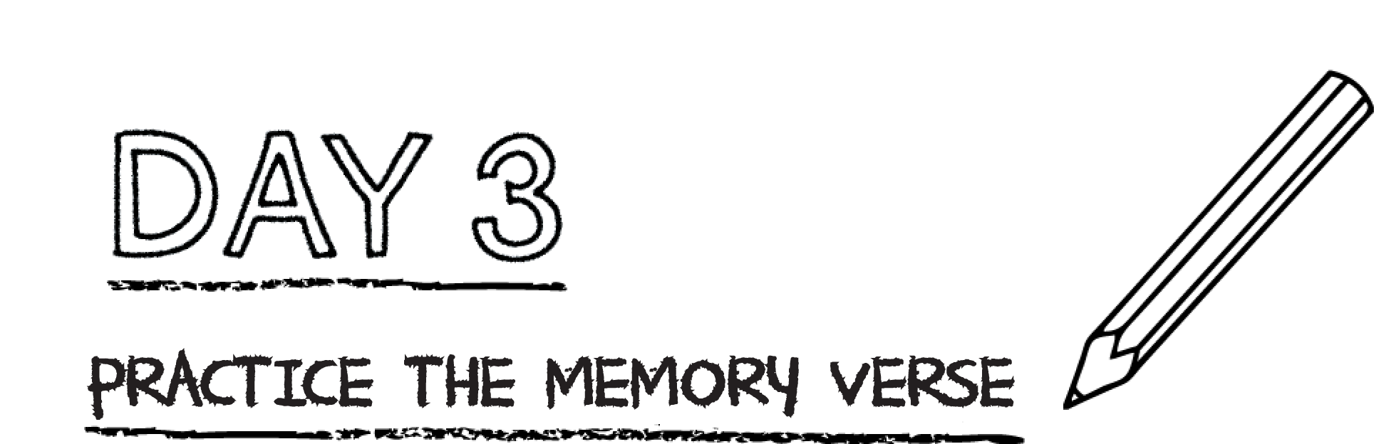

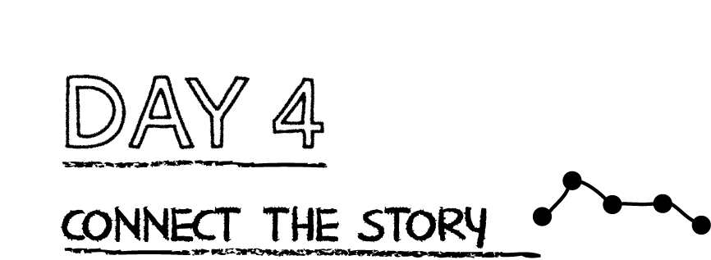

**God saved Moses’ life and called him to rescue God’s people from slavery. The calling of Moses points to a greater calling and rescue—the call of Jesus to come to earth to save God’s people. Jesus gave up His life to save us from slavery to sin.**

**Read Hebrews 7:25.** How does God save us?_________________________________________

**Moses was called to save God’s people from slavery to the Egyptians. Jesus saves us from slavery to sin. Draw a picture of yourself on the left holding your sin. Then draw a picture on the right without any sin.**

**Practice the memory verse, Hosea 13:4 CSB.**

**K-3rd Grade:** Practice the verse by singing it. Watch the worship video on our RidgeKids Teays Valley FaceBook group and sing along.

**Pray:** Dear God, I want to know you. You have always been my God and always will be there is no one like you. Help me to know you. Amen.

*.*