

**Answer the following questions.**

Who came and bowed down before Joseph?_____________________________________________

Did Joseph know who they were?_________________________________________________________

Did the brothers recognize Joseph?_______________________________________________________

Joseph said that the brother’s plan was for evil, but God’s plan was for____________________

**Prayer:** Dear God, even when things seem bad, help me to remember that your plan is for good. Amen.

**Read the story “Joseph’s Dreams Came True.”**

K-1st: Read page 26 in the Big Picture Storybook Bible

2nd-3rd grade: Read Genesis 42:1-3, 7-8, 43:29-31, 45:1-8 in the Big Picture Interactive Bible

Watch the story, “Joseph Saved His Family” on the RidgeKids Teays Valley Facebook group.

Videos are posted on Facebook every Monday.

**Prayer:** Pray just like Joseph’s brothers intended to harm him, the people who crucified Jesus, intended to harm him. But you meant all this for good. Help me to trust your plan. Amen.

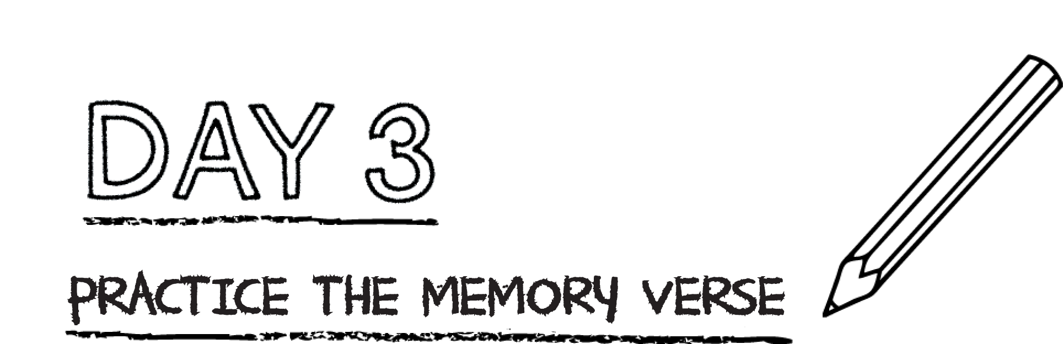

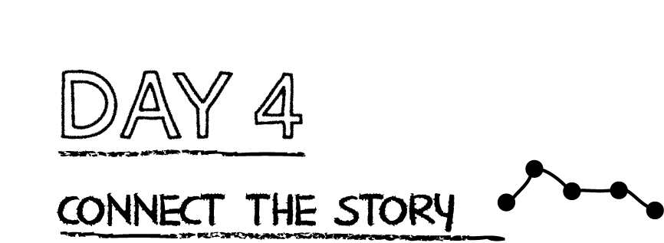

**God had a plan for Joseph’s life. He allowed Joseph to suffer to rescue a whole nation. In a greater way, God planned for Jesus to suffer so that many—people from all nations—would be saved from sin.**

**Read 1 Timothy 2:3-4.** What does God want for all people?

_______________________________________________________________________________________

_______________________________________________________________________________________

**Write the words: “GOD’S PLAN SAVES” in large letters in the space below. Then pray and thank God for including you in his plan to save people.**

**Practice the placing by filling in the blanks.**

“I have been Yahweh your ___________________ ever since the land of

______________________; you know no God but _____________________, and no

___________________________________ exists besides Me.” Hosea 13:4

**Prayer:** Dear God, help me to seek only you God and remember that there is no god besides you. Amen.

*.*